Name: **InvoiceGUI**

Description: **Chapter 10 – Programming Exercise 1**

**View invoice information**

Write a C# GUI application that instantiates objects of two classes named Invoice and OverdueInvoice, and that demonstrates all their methods. The Invoice class includes auto-implemented properties for the name of the company to whom the invoice is owed and for the amount due. Also, include a ToString() method that overrides the Object class’s ToString() method and returns a string that contains the company name, amount owed, and associated message text. Create a child class named OverdueInvoice that includes an auto-implement property that holds the number of days the invoice is overdue. When the user clicks a button, demonstrate that the Invoice class and the OverdueInvoice class are appropriately used to display the information contained in the message shown. The displayButton is to be designated as the Accept button. The exitButton is to be designated as the Cancel button. Access Keys are to be assigned to all buttons on the GUI. Set the Tab index to a logical order. Design your GUI as shown.

*Note: When building the GUI set the Character Casing property to Upper for the Invoice textbox.*

Define the Invoice class in a *separate* class file within the InvoiceGUI project.

Define the OverdueInvoice class (within the Form1 class) underneath the closing brace associated with:

public partial class Form1 : Form

Use the following field values when building your application:

Company Name Invoice Amount Days Overdue

ELECTRIC COMPANY 125.25

WATER COMPANY 175.75 60

MORTGAGE COMPANY 750.50

Create a Click event method for the displayButton. Within the method, clear display Label contents, instantiate the Invoice class (twice) and the OverdueInvoice class (once). Determine which company name the user entered and store the appropriate values in the appropriate class fields. Display the invoice information message to the user using the Invoice class fields and the OverdueInvoice (when applicable) class field. Items in the display label are to appear as shown.

Create a Click event method for the exitButton that terminates the application.

Complete the Pseudocode Template document for this programming request. A printed version is due upon arrival to class on lab day.

Use your completed Pseudocode document to create the C# application. Create and save the application to your classroom USB flash drive.

***\*\*\* Sample Program Output on Next Page \*\*\****

GUI When Started Sample Program Output (1)

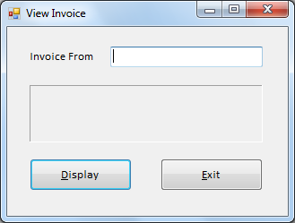 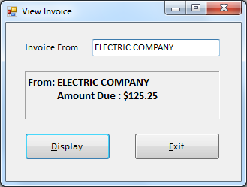

Sample Program Output (2) Sample Program Output (3)

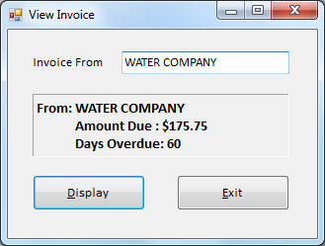 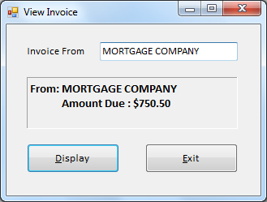

Sample Program Output (4)

